MUSIC AND MENTAL HEALTH

CIS 9655: Data Visualization

Professor Vincent Alonzi

Group 7

Anders Stachelek - [anders.stachelek@baruchmail.cuny.edu](mailto:anders.stachelek@baruchmail.cuny.edu)

Harini Mittal - [harini.mittal@baruchmail.cuny.edu](mailto:harini.mittal@baruchmail.cuny.edu)

Jenny Yu - [jenny.yu2@baruchmail.cuny.edu](mailto:Jenny.Yu2@baruchmail.cuny.edu)

William Forero - [william.forero1@baruchmail.cuny.edu](mailto:william.forero1@baruchmail.cuny.edu)

Yoon Young Kim - [yoonyoung.kim@baruchmail.cuny.edu](mailto:yoonyoung.kim@baruchmail.cuny.edu)

# 

**TABLE OF CONTENTS**

Abstract 3

Introduction 3

Domain Background 4

Data and Task Abstraction 4

Methods and Tools 5

Analysis 7

1. Selection of variables 7

2. Data Visualizations 8

Milestones 26

Key Takeaways 26

Discussion and Future Work 27

Challenges 28

Conclusion 29

Bibliography 30

# 

# 

# Abstract

Music therapy has increasingly been recognized for its potential in improving mental health outcomes for individuals suffering from mental illnesses, specifically, anxiety and depression. This paper provides an analysis and visualization on the relationship of music and reported mental health scores for anxiety and depression. Using different visualization tools we examined the effects of music reported on surveys collected from 612 participants. In general, we found that listening to music has favorable effects on mental health. Our findings reveal that participants who reported the music worsened their anxiety favored the genres pop, video game, and classical music. Those that reported improvements in their anxiety favored genres of latin, country, jazz, and gospel. Participants who reported worsening in their depression favored classical, rock, and video game music. Those that reported improvements in their depression with lower average levels of depression favored kpop, r&b, gospel, and country music.We also identified patterns in time spent listening to music and BPM, finding that music preferences vary according to age demographics. These findings would suggest that our partnership with Spotify is best served by creating curated playlists tailored to improving anxiety and depression focusing on specific genres such as country, folk, gospel, jazz, kpop, and latin, timing and BPM. Overall, the survey results suggest further research into the usage of music as a therapeutic tool, which could have positive benefits for those suffering from anxiety and depression. Given that the primary dataset focuses exclusively on four specific mental illnesses, we identified a secondary dataset, "Global Trends in Mental Health Disorders," to expand our understanding of the global prevalence of seven mental illnesses. This secondary dataset includes anxiety and depression, which are also covered in the first dataset, along with five additional mental illnesses unique to the secondary dataset. Our analysis revealed three distinct clusters of anxiety and depression trends in the global dataset, similar to the first database. We also found relationships between different mental illnesses. Based on our visualization results, we propose expanding our curated music therapy services in three phases to benefit additional mental illnesses. Our broader audience will eventually include people worldwide seeking resources to improve their mood and mental well-being.

# Introduction

The purpose of this analysis is to find which relationships exist between music, its different characteristics such as BPM and genre, individual’s listening time, and the impact such variables may have on self-reported mental health scores. By analyzing the different characteristics of music and the relationship people have with it, if any, we can better understand where to focus our efforts with partners such as Spotify in creating resources for those suffering from different mental health conditions.

The worldwide levels of anxiety and depression have generally not had any major shifts in the last 10 years. Alternative treatments, including music therapy, have gained traction. Recognizing this shifting landscape, our investigation seeks to decipher the impact of music on mental health outcomes. To that end, we analyzed a dataset that pooled the effects of music on the mental health of individuals who participated in a survey to find any significant relationships between music, its various components, and the impact it may have on mental health.

This project utilizes two datasets from Kaggle. The first dataset, “Music and Mental Health Survey Results”, served as the main source of our findings, which comprise of 32 survey questions surrounding different musical aspects and their relationships with anxiety and depression. We supplemented this with another Kaggle dataset, “Global Trends in Mental Health Disorders”, which provided a general trend in worldwide anxiety and depression ratings over the last 10 years.

# Domain Background

In today's societies, mental health disorders like anxiety, depression, schizophrenia, and eating disorders are prevalent and negatively impact many lives. Unfortunately, many who are facing these challenges may find it difficult to seek the support they need. Recognizing the urgency of these issues, our group conceived the idea of using music therapy to address pressing mental health conditions. We are a startup company specializing in music therapy, hoping to collaborate with music streaming platforms to create resources to help those with mental health disorders. Music therapy is a specialized form of therapy that utilizes music as a therapeutic tool. Our clients can use music for a variety of activities, such as listening, singing along with, and playing music. Music therapy holds a promising future, and we hope that our analysis can inform and persuade others the benefits of music on mental health disorders.

# Data and Task Abstraction

We used two datasets to help us develop our visualizations in support of music therapy, both of which were obtained from the Kaggle website. Our primary dataset - [Music and Mental Health Survey](https://www.kaggle.com/datasets/catherinerasgaitis/mxmh-survey-results) - consisted of survey results of 736 participants in total across 32 survey questions. Our supporting dataset - [Global Trends In Mental Health Disorders](https://www.kaggle.com/datasets/thedevastator/uncover-global-trends-in-mental-health-disorder) - consisted of almost 109,000 observations across 276 unique countries, across a total of 10 different characteristics or demographics. In order to facilitate analysis, both datasets were cleaned by removing unnecessary columns, any rows with missing values, any significant outliers or erroneous values, and narrowing years to those between 1999 to 2019. Furthermore, some quantitative variables were converted to categorical variables through the use of intervals that dictated the prevalence of the observation of the variable. As shown in Table 1, the following categorical values were used to better define the self-reported values by the survey participants across the various mental health disorders, ranging from no evidence of the disorder to a high prevalence of the specific mental health disorder.

| Categorical  Representation | Mental Health Disorder  (Anxiety, Depression) |
| --- | --- |
| No | 0 or 1 |
| Low | 2 to 4 |
| Medium | 5 to 7 |
| High | 8 to 10 |

Table 1. Conversion from quantitative self-reported value of mental disorder to categorical description.

Through this process, our primary dataset was reduced from the original 736 responses to 612 participants and from 32 survey questions down to 11 survey questions that served as our variables for analysis to support the potential use of music as a means to promote mental health. For our supporting dataset, the overall observations were reduced from nearly 109,000 down to 3,724 overall observations across 196 countries, with a focus on 3 characteristics and demographics of interest. The finalized comprehensive list of variables selected for analysis from two datasets is outlined in Table 2.

| Primary Dataset -  [*Music and Mental Health Survey*](https://www.kaggle.com/datasets/catherinerasgaitis/mxmh-survey-results) | Supporting Dataset -  [*Global Trends In Mental Health Disorders*](https://www.kaggle.com/datasets/thedevastator/uncover-global-trends-in-mental-health-disorder) |
| --- | --- |
| * Age * Primary Streaming Service * Hours Per Day * Favorite Genre * BPM * Frequency (16 music genres) * Anxiety * Depression * Insomnia * OCD * Schizophrenia * Bipolar disorder * Eating disorder * Music Effects | * Code * Year (1999 -2019) * Anxiety disorders (%) * Depression (%) |

Table 2. Key variables for our analysis from two datasets.

# Methods and Tools

For the data visualizations, our primary tools were Tableau and R Studio. We used R Studio for data cleaning and saved the dataset as csv files that were uploaded and shared in our group document folder. Using these files, we used Jupyter Notebook in Google Colab to do some variable analyses. We utilized the available libraries in Python, such as matplotlib.pyplot and seaborn, to create a heatmap for correlations across the different mental health scores. Using the iloc command, we selected the desired variables (columns) to facilitate the investigation using the correlation matrix. In the following three figures, we provide the specific steps implemented to create the correlation matrix across the mental health disorders in our primary dataset.

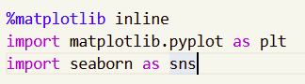

Figure 1: Importing the necessary libraries to make a visual

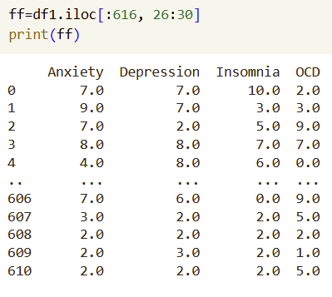

Figure 2: Selecting desired columns with iloc

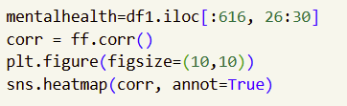

Figure 3: Code used to create the correlation matrix heatmap

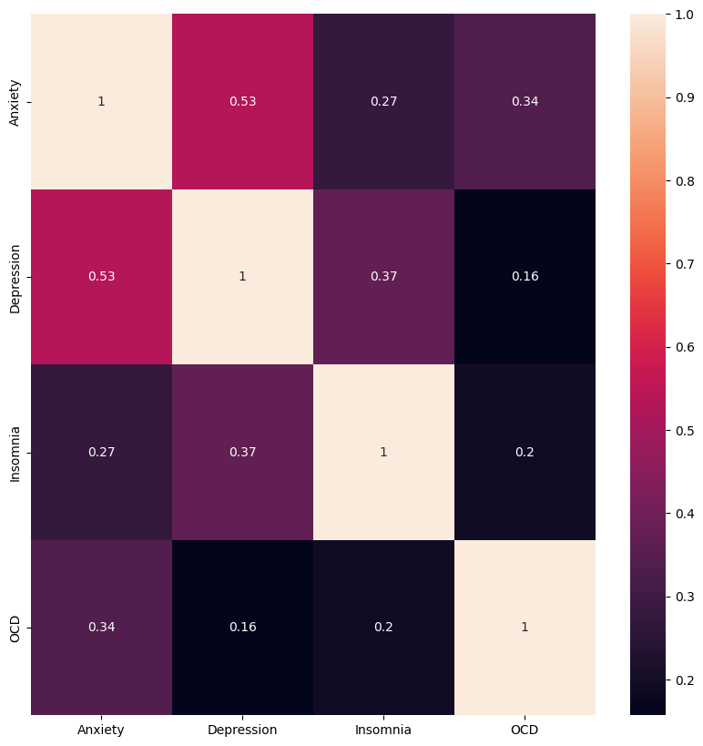

Figure 4: Correlation matrix between mental health variables in primary dataset, showing the strongest correlation is between anxiety and depression

# Analysis

## Selection of variables

From the correlation matrix in Figure 4, we can easily see that anxiety and depression have a moderate correlation, at a value of 0.53. Additionally, the mental health disorders of anxiety and depression were the only mental health disorders that were mentioned in both our primary dataset and our supporting dataset. Therefore, we decided to solely focus on these two disorders and hoped it would provide some interesting insights.

Some other variables we figured would help us in identifying the benefits of music therapy and provide interesting insights would be individuals’ favorite genres, the effects of music on their mental health, the primary streaming services used, the age groups and their listening patterns, how many hours one spent listening a day, the beats per minute per genre, the frequency of listening to a specific genre, and music effects such as whether it improves, does not affect, or worsens their disorder.

## Data Visualizations

***A View Of Anxiety Throughout The Years***

The supporting dataset consists of data from the years 1999 to 2019 on the percentage of people with specified mental disorders within each year. In Figure 5, we looked at the average percentage of the population affected by anxiety across the years, adjusting the values of the axis to be able to see the overall trend more clearly. The axis has been altered so the starting point would be 3.94 and the subsequent intervals are 0.001 apart. We can see that there is a slight increase of anxiety worldwide, even though the change in the average is miniscule. From this, we can tell that anxiety has not improved over time and that is why we hope to change this by introducing music therapy.

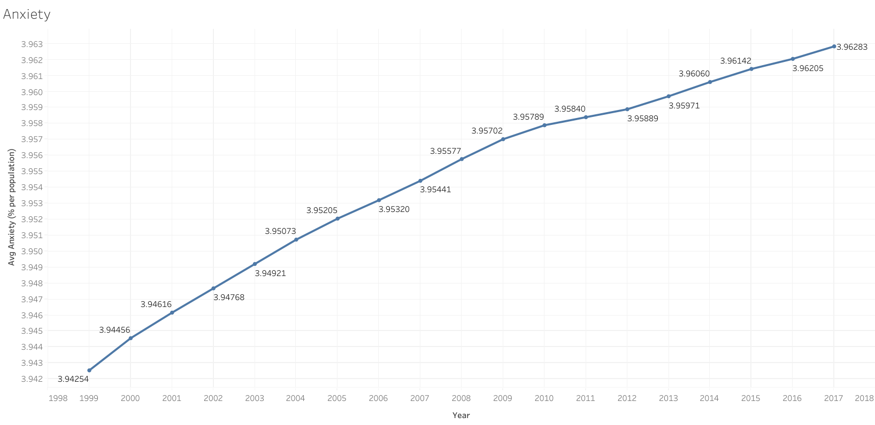

Figure 5: Line chart showing average percentage of population of anxiety over the years

***A View Of Depression Throughout The Years***

In Figure 6, we looked at the average percentage of the population affected by depression throughout the years. Once again, we adjusted the values of the y-axis to see the trend more clearly. In this case, our minimum value is 3.40 and we retained the interval of 0.001. The trend appears to be decreasing; however, the change in values from one year to the next was infinitesimal (in the hundredths place) for each value, which is more indicative of a constant rate, and thus almost no change over the years.

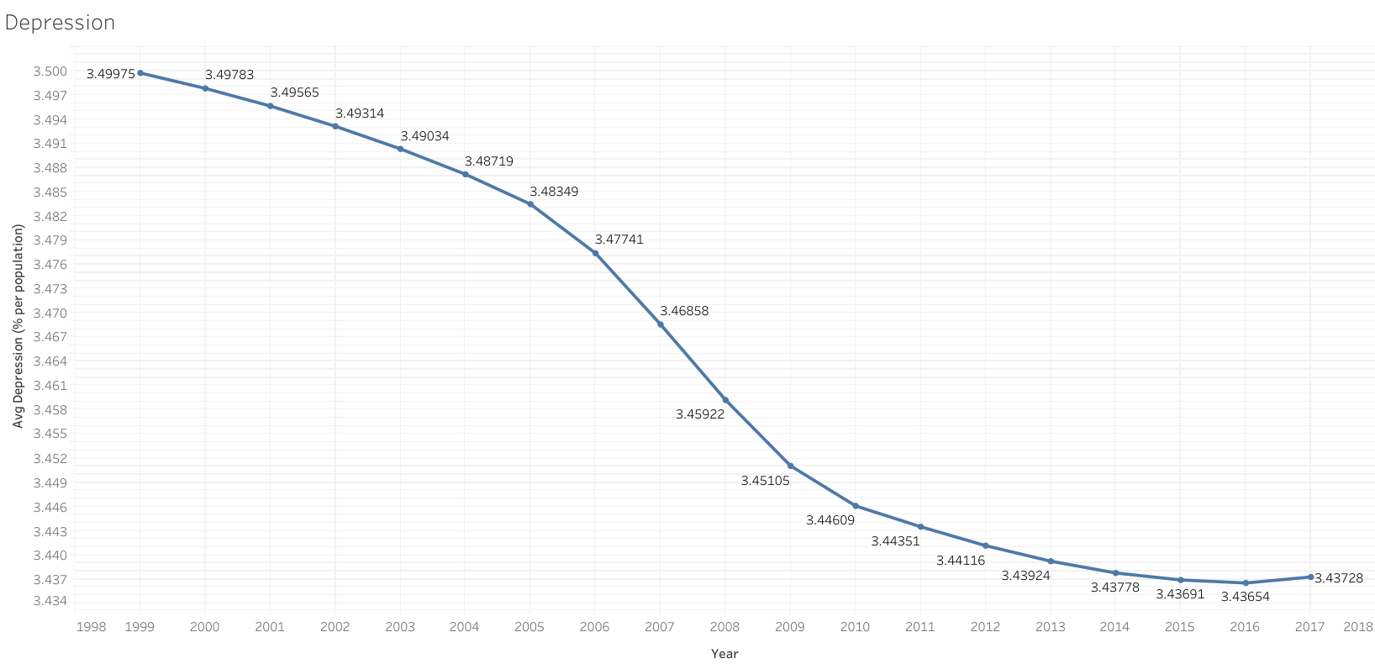

Figure 6: Line chart showing average percentage of population of depression over the years

***Anxiety across the World***

Since our supporting dataset provides information on mental health across the world, we wanted to create a visual of a world map to clearly see the prevalence of anxiety across different countries. Figure 7 shows a choropleth map of the average percentage of the population reported to have anxiety disorders. The darker shades of purple indicate countries with higher percentages of the population who suffer from anxiety. The highest countries were Australia, Argentina, Brazil, United States, Canada, Greenland and New Zealand. This finding highlights how prevalent anxiety is and how many individuals across the world are impacted by it.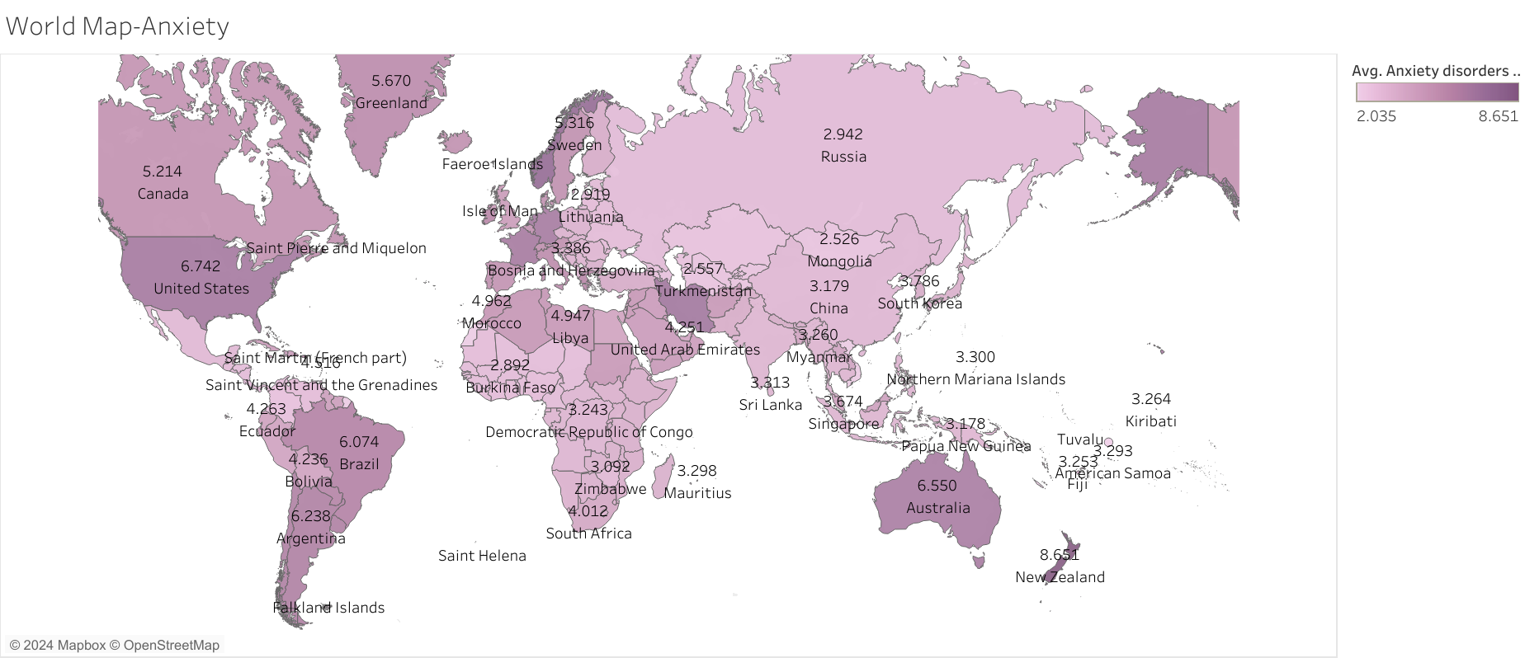Figure 7: Choropleth of world map showing population percentage who suffer from anxiety

***Depression across the World***

Similarly, we also wanted to see a world map view of depression shown in Figure 8, the darker shade would represent the more depressive country. Interestingly, Australia, Greenland, and the United States, were the countries with high anxiety and here we see they also have high depression. Once again, it shows that anxiety and depression are correlated and an individual that has anxiety may also experience depression and vice versa. This is why we hope to use music therapy to help in alleviating any symptoms of those with anxiety and depression.

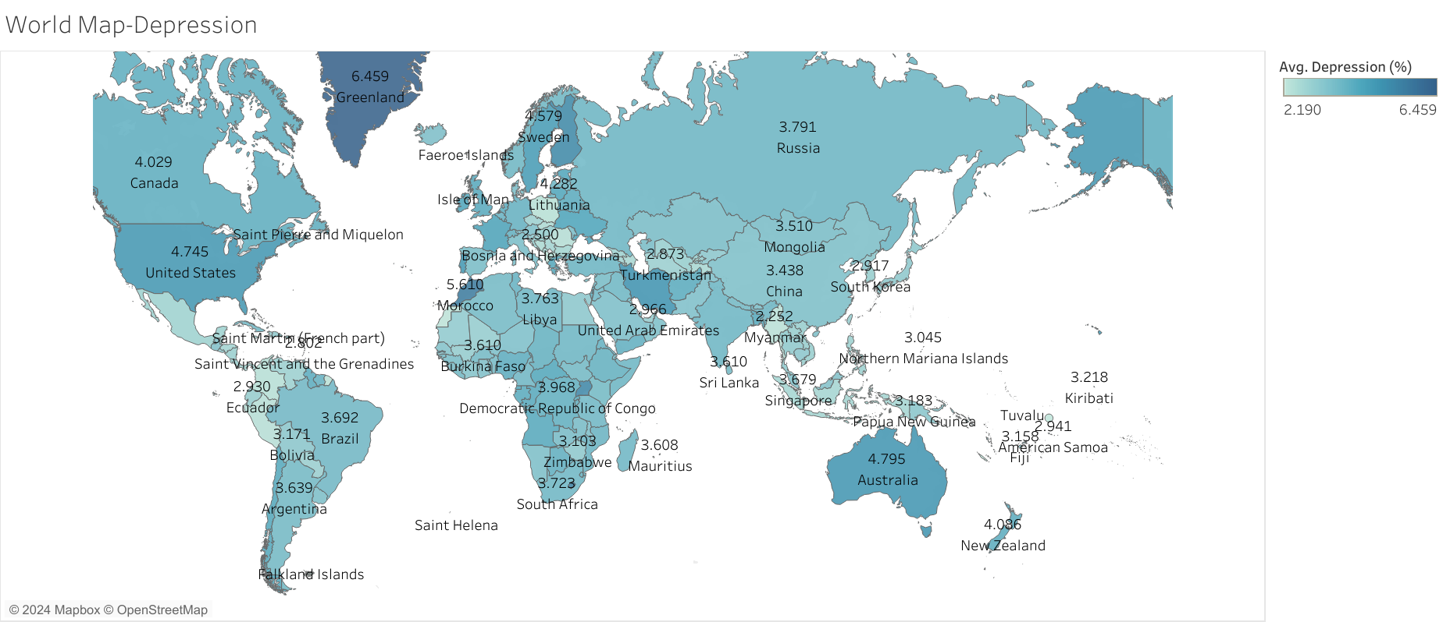

Figure 8: Choropleth of world map showing population percentage who suffer from depression

***Clusters of Anxiety and Depression***

Expanding on this analysis, Figure 9 utilized the supporting global data on global mental illness that highlights the trends revealed through three distinct clusters of anxiety and depression that arose, each with an average percentage of the population affected in those regions. Consequently, we can leverage these insights to target global markets more effectively. Of the 196 countries analyzed, 19 fell into the high anxiety and depression cluster (red stars), 9 into the medium cluster (blue squares), and 119 into the low anxiety and depression cluster (orange circles). The 28 countries in the higher levels of anxiety and depression may be a stronger market for our services than those with lower levels of anxiety and depression.

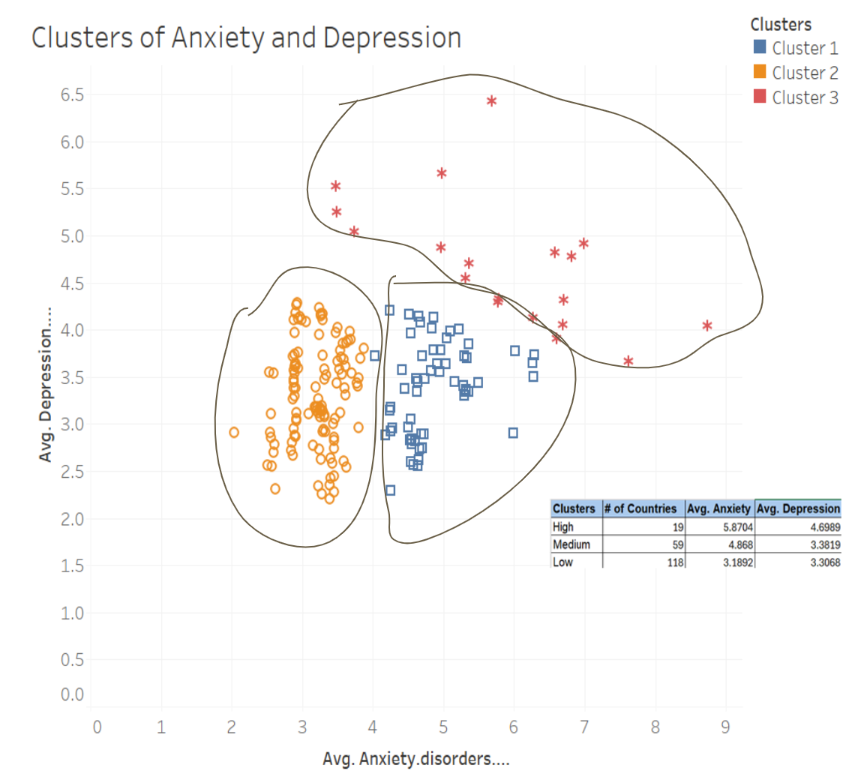

Figure 9: Clusters of varying levels of anxiety and depression across 196 countries

***Mental Health Disorders Interrelationships***

Figure 10 heatmap is based on the supporting global mental health dataset, demonstrating that anxiety disorders are globally correlated with schizophrenia, bipolar disorder, and eating disorders. This finding suggests the potential to reach a broader population with correlated mental health disorders using similar genres, BPM, and timed playlists.

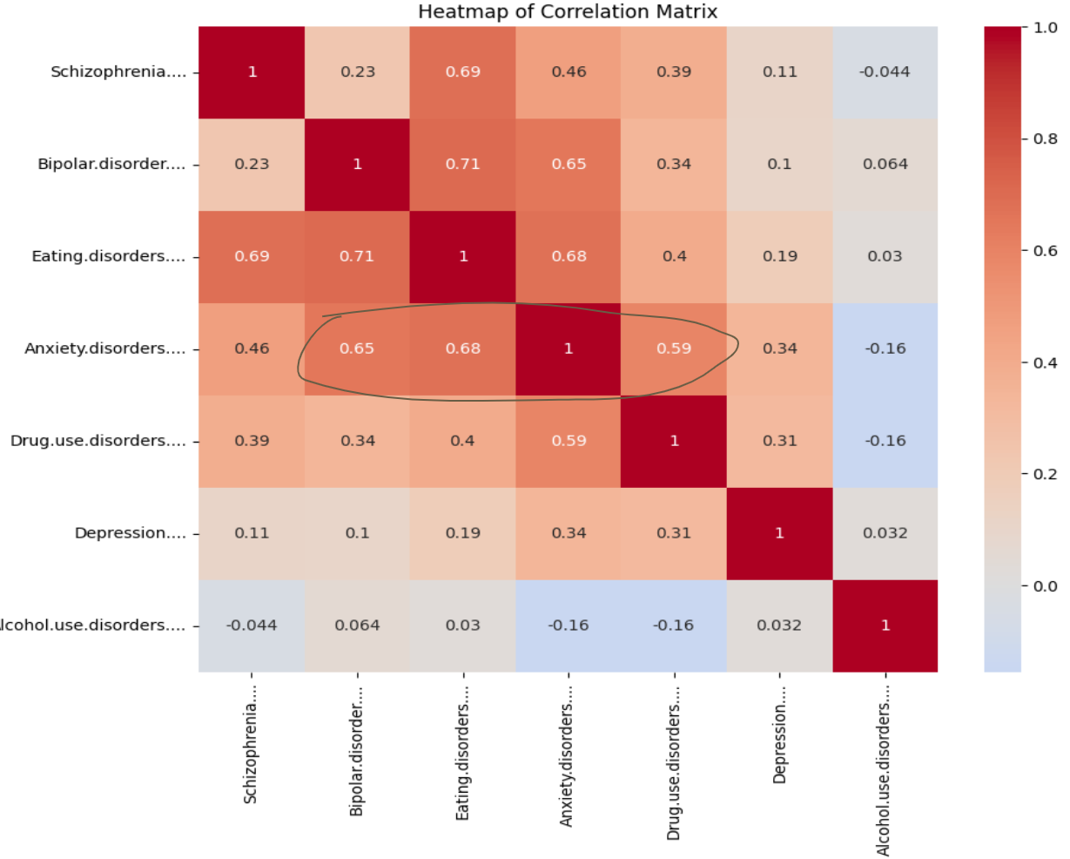

Figure 10: Global trends in mental disorder interrelationships

***Collaborating with Music Streaming Services***

One of our main objectives is to collaborate with music streaming services to spread the idea of using music as a form of therapy. In our primary survey dataset, one of the variables was primary streaming services, which indicates the service that the participants typically use to listen to music. Based on Figure 11, it was evident that Spotify was the top streaming service used and because of this, we are eager to work together to create suitable playlists in Spotify for those with anxiety and depression. We want everyone to experience the benefits of music therapy, so it is crucial for us to partner with streaming services that are competitive in the market to ensure widespread access to music therapy.

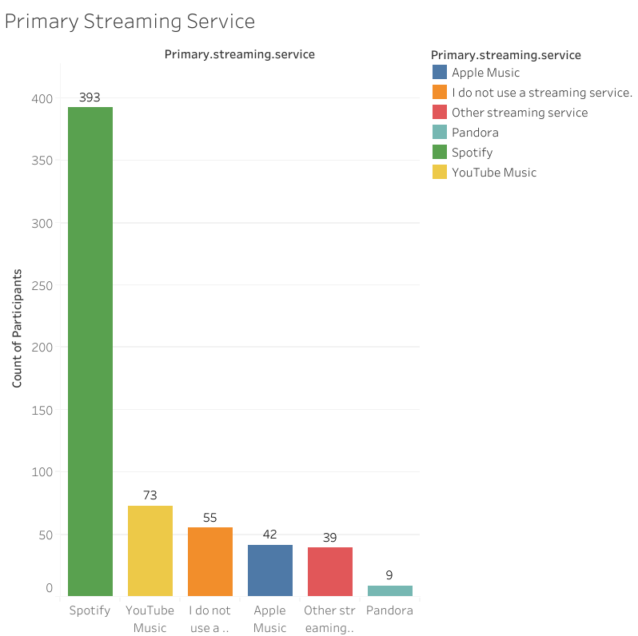

Figure 11: Bar chart showing primary streaming service used by participants

***Favorite Genres***

When we think about music, we immediately think about our favorite genres. From our primary survey dataset, we knew analyzing favorite genres among the participants would provide valuable information because it can give us insights on the listening patterns to help develop a playlist. Therefore, we went in depth with analyzing genre along with many other variables that will be discussed in the remaining sections.

In Figure 12, we wanted to uncover the most common genre that the participants chose, finding that rock, pop, metal, and classical were among the top genres. However, this does not indicate these genres have a positive effect on mental health disorders. Therefore, we conducted further analysis to identify the genres that appear to have a positive effect and use this information to create playlists that will be beneficial to those who suffer from mental disorders.

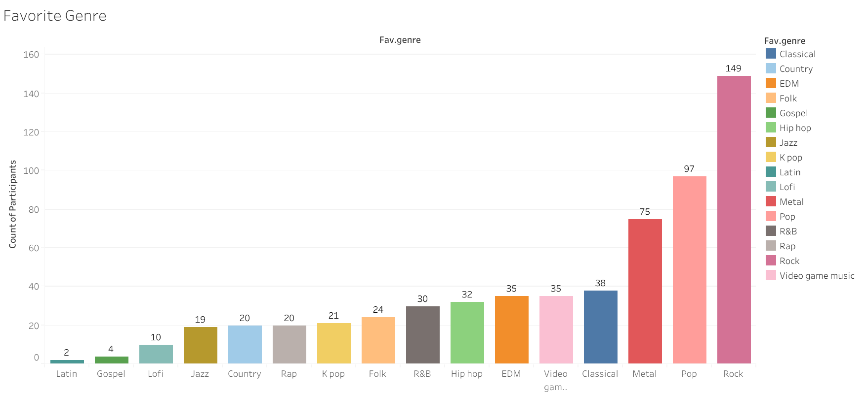

Figure 12: Bar chart showing favorite genre of participants

***Favorite Genre and Frequency***

Next, our group analyzed the genres in relation to the frequency individuals listen to each genre and to the genre’s typical BPM. Figure 13 illustrates the number of counts for each frequency of listening across each genre. For example, rock music and pop genres exhibit the highest count of very frequent songs across survey participants. Conversely, gospel, latin, and kpop report the highest count of "Never" for listening frequency. These results further support our previous analyses that streamers very frequently listen to their favorite songs, with gospel music having the smallest fan base.

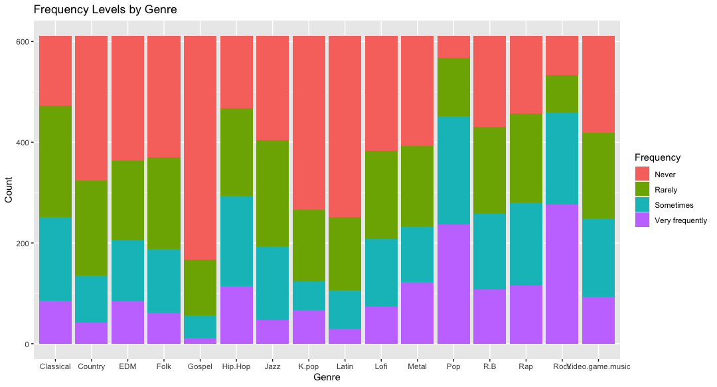

Figure 13. Frequency by Genre

***BPM for each genre***

Figure 14 depicts the various BPM ranges for each genre. Interestingly, r&b, hip hop, and gospel genres display a wide range of BPM levels, spanning from a minimum of 10 to over 150 BPM. Conversely, rap, lofi, latin, and country genres have a narrower range of BPM levels, typically on the higher end, around 70 to 170 BPM.

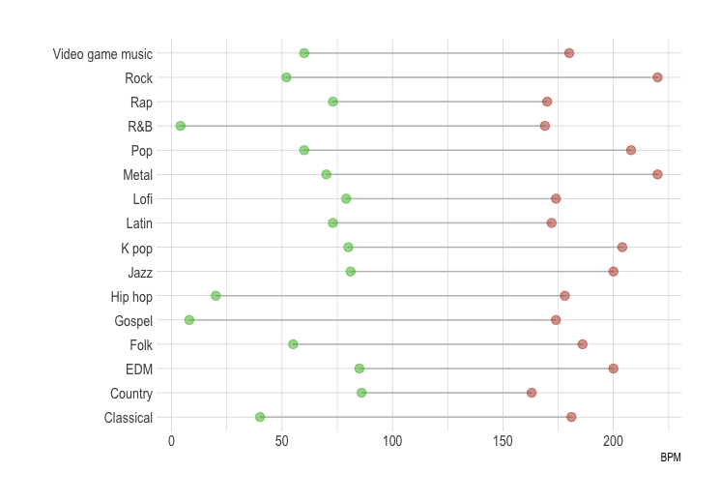

Figure 14. Range of BPM for each Genre

Understanding BPM ranges is crucial for streaming services as it aids in algorithm development and playlist curation. Accurate BPM data allows algorithms to recommend songs that match a listener’s current activity or mood, enhancing the user experience. This targeted approach can increase user engagement and satisfaction, driving subscription retention and growth.

In the realm of musical therapy, BPM ranges play a significant role in therapeutic outcomes. Different BPM levels can evoke various physiological and emotional responses. Understanding the BPM characteristics of different genres allows therapists to tailor interventions to individual needs, whether it's reducing anxiety, improving mood, or assisting in physical rehabilitation.

***Investigating the Relationship between Genre and Music Effects***

Our group proceeded to examine the relationship between genre and music effects on mental health. The analysis reveals that each genre can elicit ambivalent effects, potentially improving, worsening, or having no discernible effect on mental well-being. As shown in Figure 15, participants who reported exacerbated mental illness often cited listening to rap, rock, and video game music. It’s important to note that this doesn’t necessarily mean that listening to these genres worsens or causes mental illness, or vice versa. The relationship between music and mental health is complex and influenced by various factors, including individual differences, context, and personal associations with the music. Therefore, further research will be needed to understand the underlying mechanisms and to establish any causal links to guide our development of streamlists.

Nevertheless, based on these preliminary findings, we recommend crafting playlists targeted at alleviating mental illness by including genres such as country, edm, folk, gospel, hip hop, jazz, kpop, latin, lofi, and metal, while minimizing exposure to classical, pop, rap, rock, and video game music.

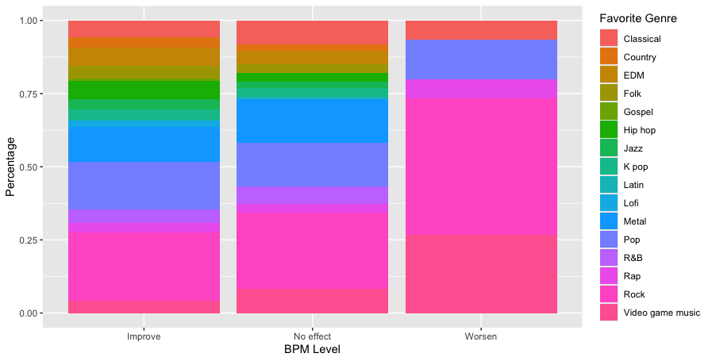Figure 15: Genre and Music Effects

***Investigating the Relationship between BPM and Music Effects***

To examine the influence of BPM levels on music effects, we began by categorizing BPM into six categories: Very Slow, Slow, Moderate, Moderately Fast, Fast, and Very Fast. The Table 3 below illustrates these BPM classifications along with examples of song types corresponding to each classification.

| **BPM classification** | **BPM** | **Examples** |
| --- | --- | --- |
| Very Slow | Below 60 | Funeral dirges, some ambient music, extremely slow classical pieces. |
| Slow | 60-80 | Ballads, slow waltzes, some jazz standards. |
| Moderate | 80-110 | Pop songs, rock ballads, folk tunes, many jazz tunes. |
| Moderately Fast | 110-140 | Upbeat pop songs, rock songs, some EDM tracks, faster jazz standards. |
| Fast | 140-170 | Dance music, techno, punk, some rock and pop songs with high energy. |
| Very Fast | Above 170 | Speed metal, hardcore techno, drum and bass, some extreme forms of electronic music. |

Table 3. Classification of BPM Levels and corresponding example songs

Looking across these new categorical BPM classifications, Figure 16 reveals that the majority of music reported by participants falls under the Moderately Fast category.

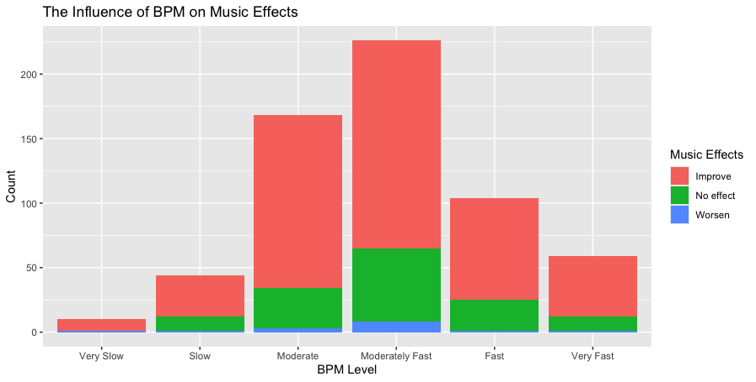

Figure 16. The influence of BPM on Music Effects

Interestingly, regardless of BPM classification, all types of music have shown to improve listeners' mental well-being. This suggests that there is no significant relationship between BPM levels and the effects of music.

***Age Group Analysis***

Our group conducted an age-based analysis, categorizing participants into age intervals: 0-19, 20-29, 30-39, 40-49, 50-59, and over 60. In Figure 17, the boxplots illustrate the mean, first (Q1), and third (Q3) quartiles for each age group. While no significant differences were observed among age groups from teenage years to the 50s, individuals over 60 tended to prefer music with lower BPM levels.

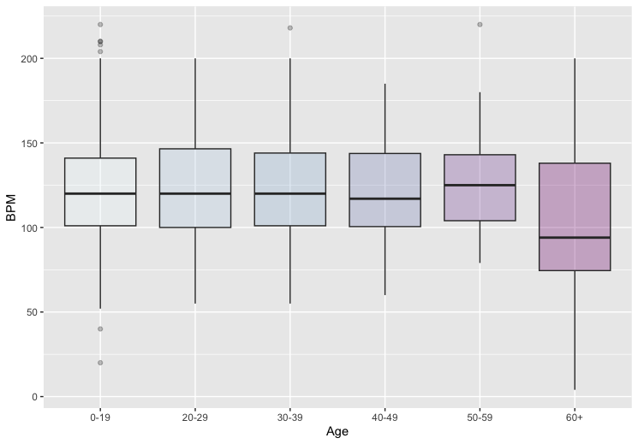

Figure 17. Box plot of BPM for each age group

As we can see from Figure 18, every age group reported positive mental health effects from music. This suggests music platforms should create age-tailored playlists. For users experiencing worsened mental health from music, we propose offering diverse calming content, safety features, and a supportive community. Continuously seeking feedback allows us to improve our platform's support for users experiencing negative mental health effects from music.

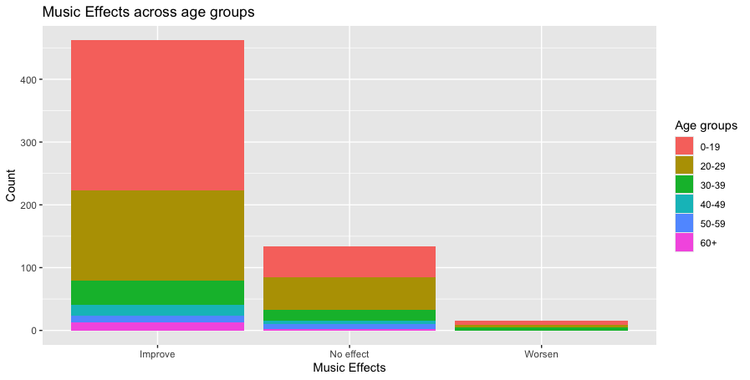

Figure 18. Music Effects across age groups

***Average scores of anxiety and depression based on genre***

We further investigated the average scores self-reported by participants for levels of anxiety and depression, as related to their favorite genre. What this revealed was that respondents whose favorite genre was folk, kpop, and video game music reported experiencing higher levels of anxiety (Figure 19). Participants whose favorite genre was lofi, hip hop, and folk reported higher levels of depression on average (Figure 20).

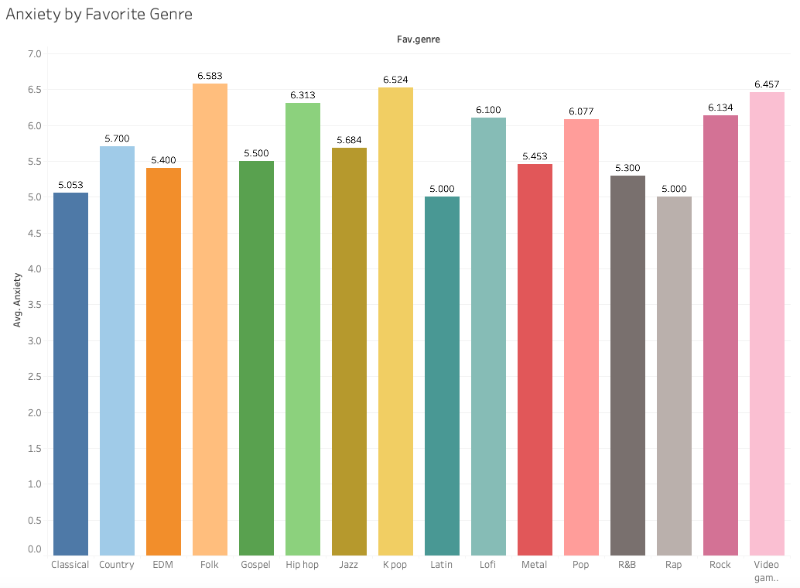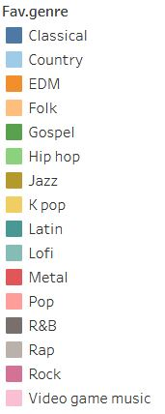

Figure 19:Anxiety by Favorite Genre

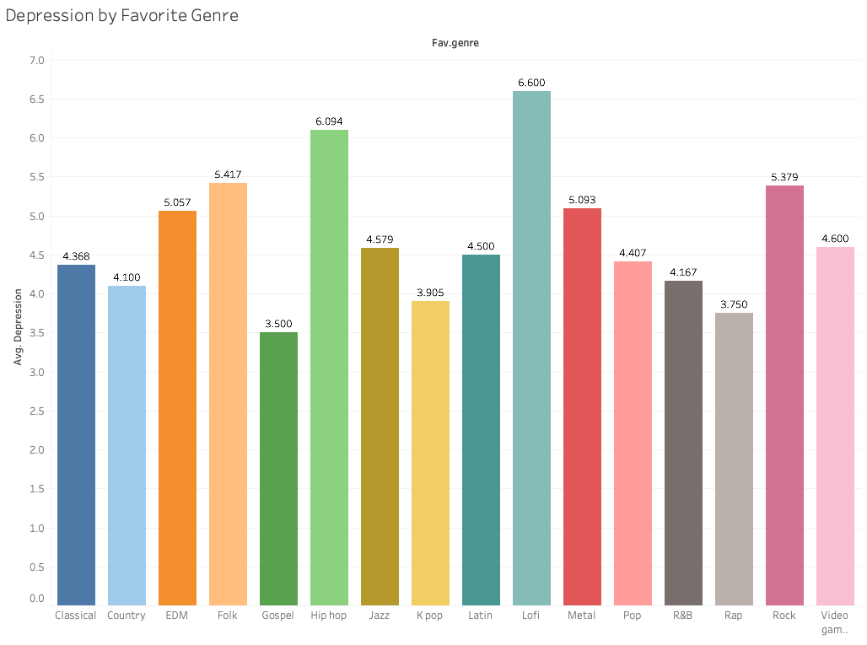

Figure 20: Depression by Favorite Genre

It is worth noting that the dataset does not specify whether these levels of anxiety and depression were recorded before or after participants listened to music. This gap indicates that it is possible that individuals whose favorite genre is folk could have higher levels of anxiety on average in general, but this does not necessarily mean it is caused by listening to folk music. To extend the analysis, we integrated the reported effects music had on the respondents in Figures 21 and 22. These tree diagrams showed that those who reported worsening anxiety with music had favorite genres of pop, classical, and video game music. As for those that reported worsening depression, the favorite genres associated with those were classical, rock, and video game music.

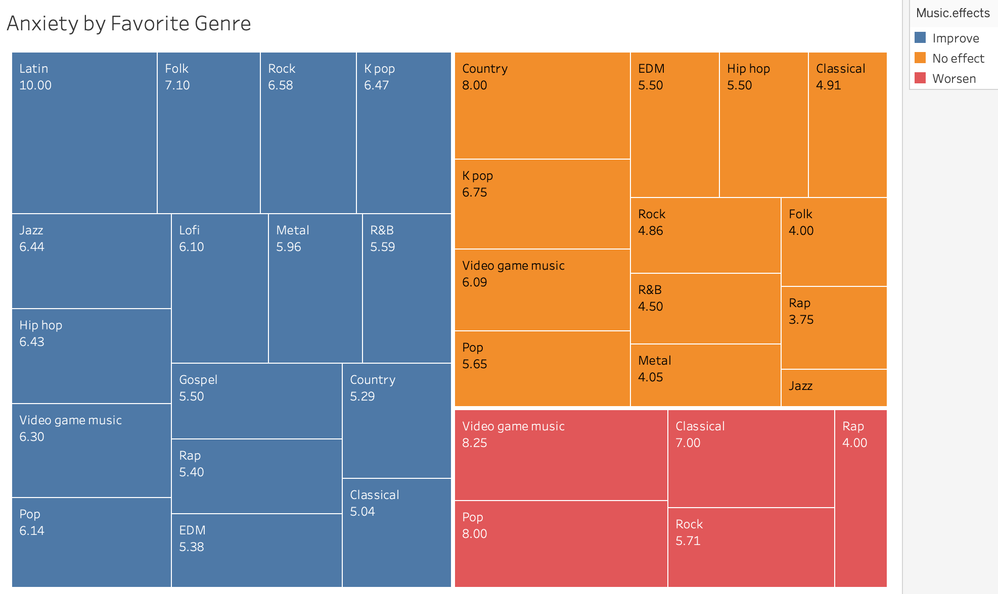

Figure 21: Anxiety by Favorite Genre and Music Effect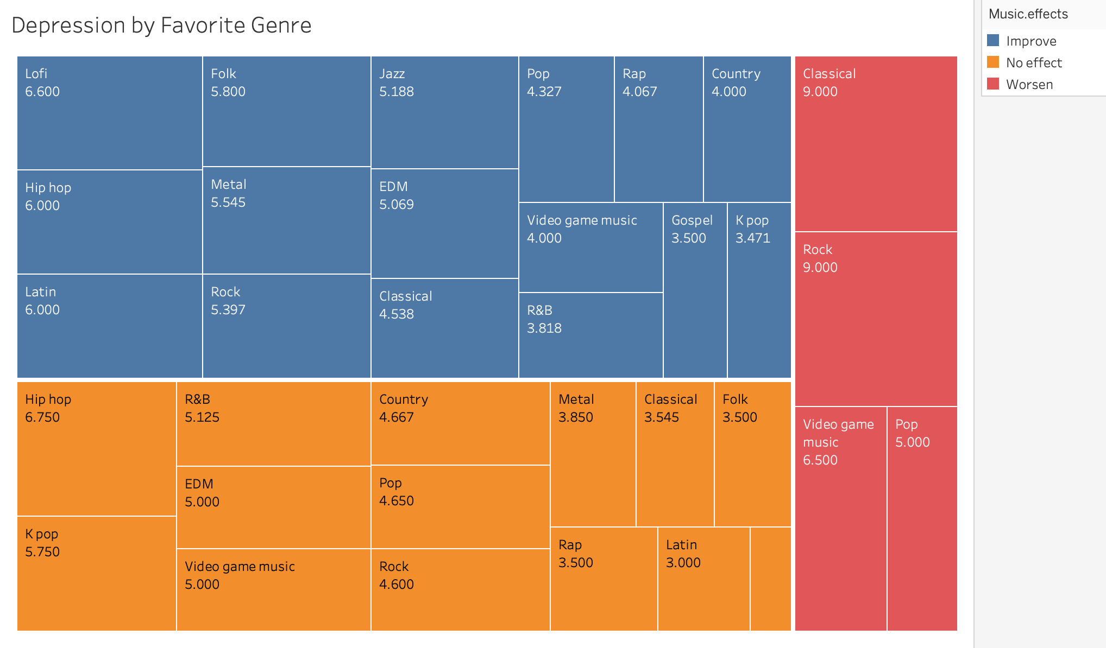

Figure 22: Depression by Favorite Genre and Music Effect

***Investigating the Relationship between Hours Spent Listening to Music and Mental Health***

In the next analysis, we related the hours spent listening to music to the self-reported levels of anxiety and depression, specifically in connection to the stated expectation of the effect music has on mental health. As shown in Figure 23, we found that the listening hours individuals reported was heavily skewed to the right, in large part due to about 70% of the survey respondents listening on the lower end of the hours per day (ranging from 1 to 4 hours), as well as a few noticeably large outliers (especially one individual report of listening for an entire day). For those individuals who stated that listening to music worsens the level of their anxiety and depression, they tended to report lower hours of listening to music compared to the other two groups of no effect and improvement. This result may be in part due to the worsening effect of music, thus minimizing their listening overall. We wonder if perhaps a different playlist may alter this effect and may subsequently increase their listening hours by altering this effect to a more positive one. Nevertheless, it is reassuring that for the most part, survey participants have stated that listening improves their mental health, furthering the need for a streaming platform focused on maximizing this benefit.

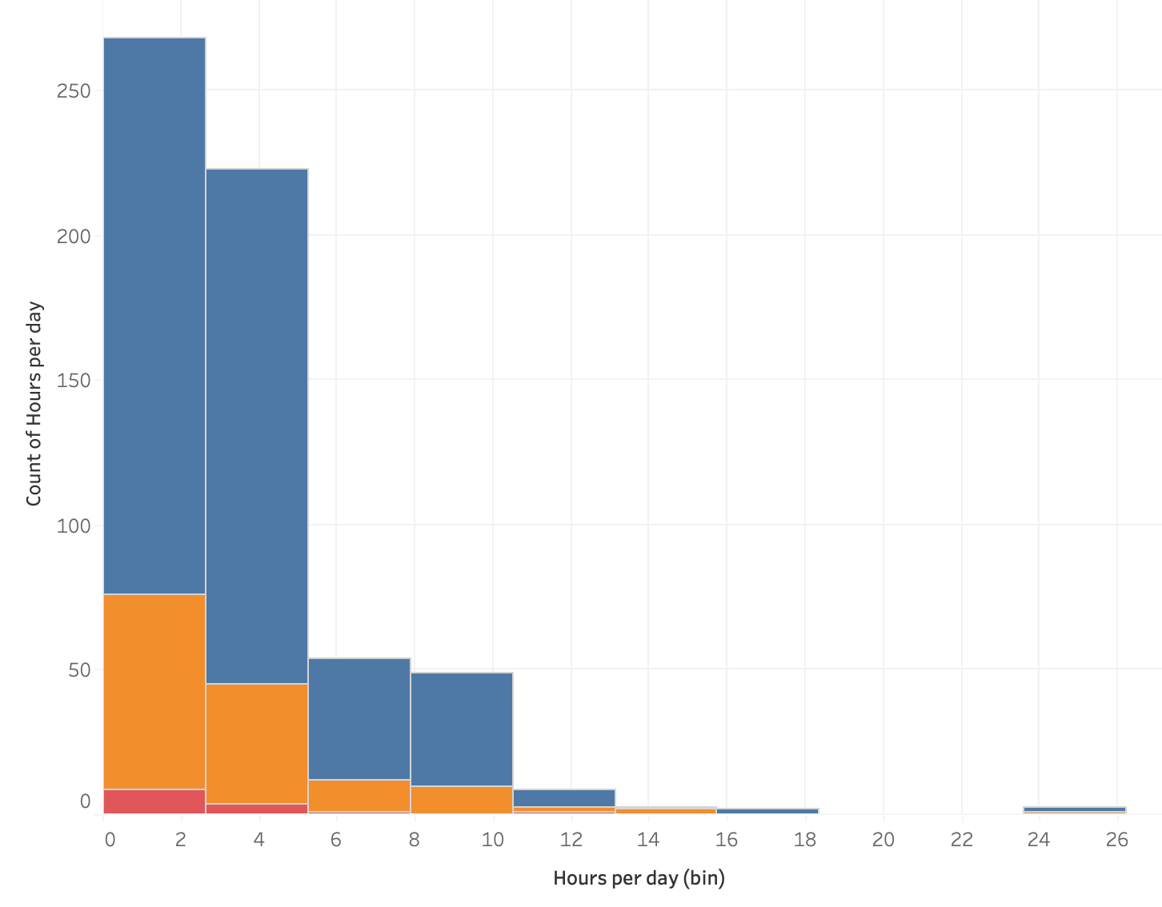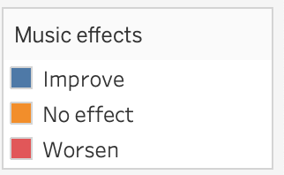

Figure 23: Histogram of the distribution of hours per day participants of the survey listen to music by music effects.

We also decided to investigate if the amount of time spent listening to music differed across age. In Figure 24, we compared hours of listening per day to the age of the survey participant. We can see in this figure that the younger ages tend to report listening to more hours of music, while older individuals listen to fewer hours.

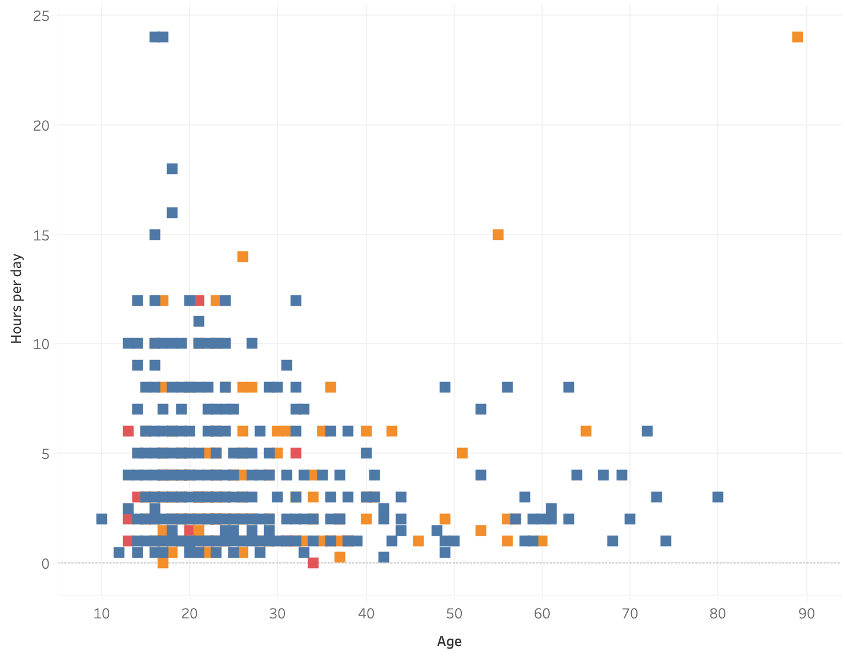

Figure 24: Scatterplot of age of the survey participants versus hours of listening per day, both in relation to music effects.

An interesting aspect of this visualization is that, within the demographic of individuals greater than 35 years of age, they report that music either has no effect on their mental health or improves it. For this reason, we argue that there is room to entice this demographic of 35+ individuals to listen to more music through a streaming platform geared towards promoting mental health and wellness, as they already recognize the benefits listening can have. From here, we focused on incorporating the self-reported ratings for depression and mental health as it relates to participants' reported listening hours. Because of the skewness of this data, as shown in Figures 23 and 24, the median value of hours listening to music was used for subsequent analysis across the various visualizations that follow and is related to the other variables of interest.

To conduct the next set of analyses, we developed multiple visualizations to look at the interactions between the hours a survey participant listened to music, self-reported mental health disorder ratings, and the self-reported effect music has on their mental health. In order to begin this investigation into listening hours, coupled with levels of depression and anxiety, we first started by looking at mental health ratings separately for each disorder. Based on the standalone anxiety and depression heat tables in Figure 25, neither depression or anxiety on its own seems to elicit any pattern across the various levels in terms of the hours individuals reported listening to music. In contrast, when we relate levels of anxiety with the respective levels of depression, we notice that individuals with high anxiety and high depression have the highest median hours of listening to music and those with no anxiety and low depression tend to also have the highest median hours listening. By focusing on the group of individuals that self-report high levels in both depression and anxiety, as shown in the combined heat table in Figure 25, we can see that there is a strong market for streaming platforms focused on high anxiety and high depression, since those individuals report a higher amount of listening hours.

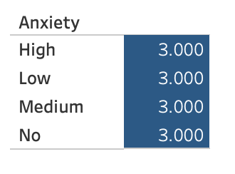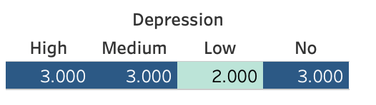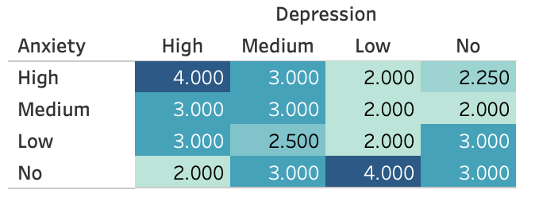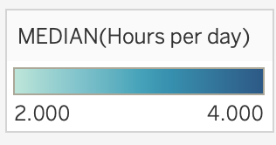

Figure 25: Heat tables across levels of depression and anxiety, shaded based on the median hours of listening per day for individuals in those respective categories.

In Figure 26, we focus on the number of hours individuals typically listen to music by creating a set of boxplots that are sorted based on the intersectional level ratings across the respective categorical descriptions for depression and anxiety. Figure 26 helps to combine information on the various levels across the mental health disorders, the hours individuals listen to music, and the self-reported effects music has on such mental health disorders.

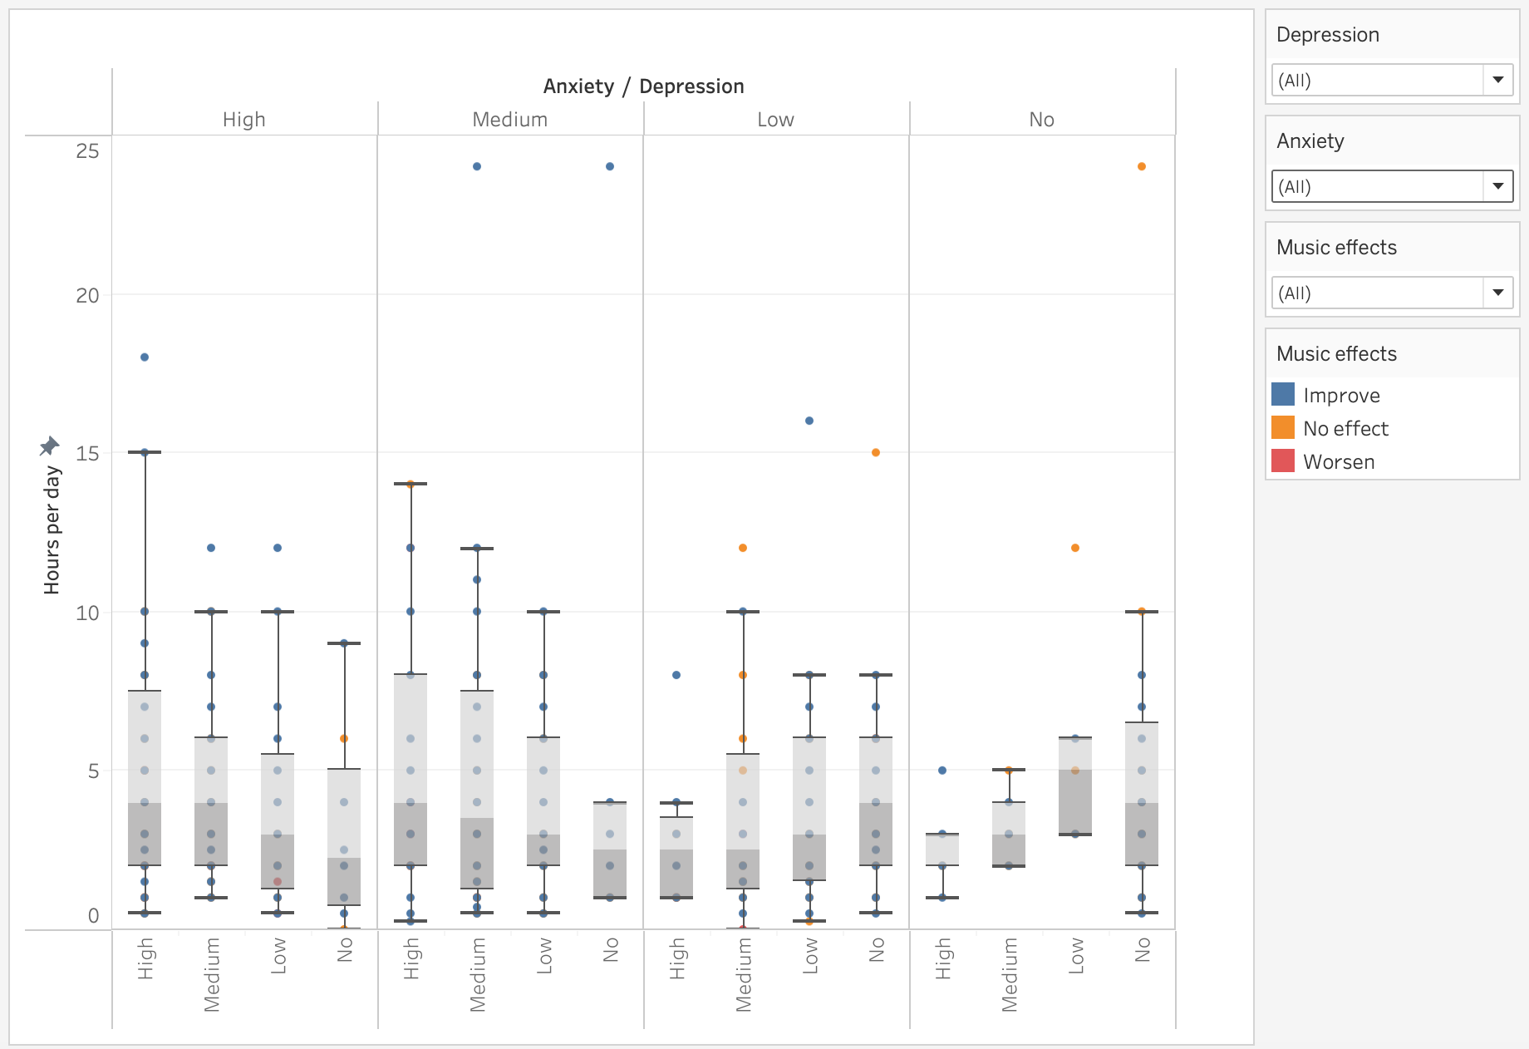

Figure 26: Boxplots of hours individuals reported listening to music across levels of anxiety and depression.

From these various boxplots, we recognize that high and medium levels of anxiety and depression combined are often related to higher overall hours of listening to music. This outcome supports the idea of working closely with streaming platforms to target individuals reporting high or medium levels of anxiety and depression. Nevertheless, this visualization only tells part of the story, as the musical effects are hard to decipher using varying colors across so many values.

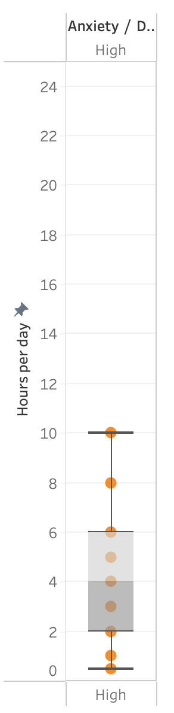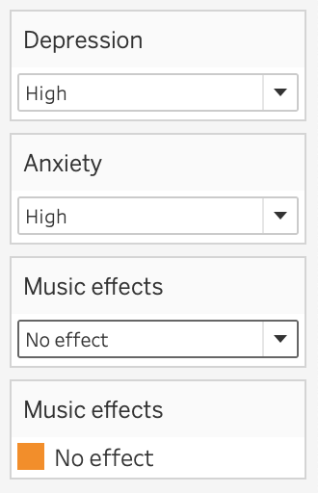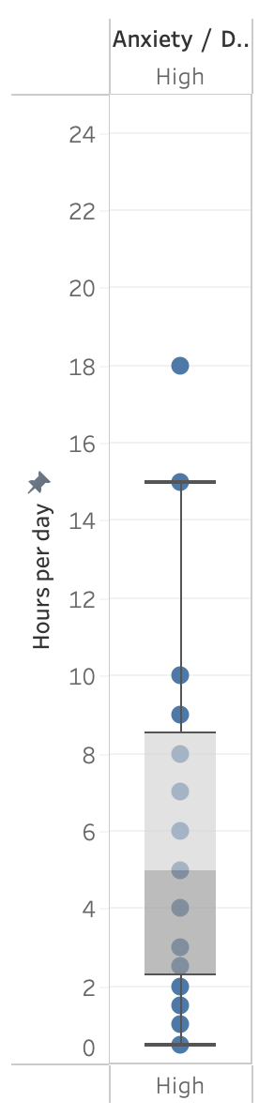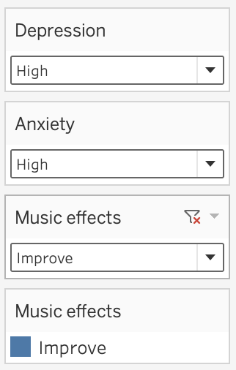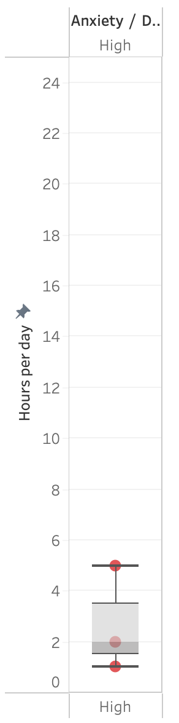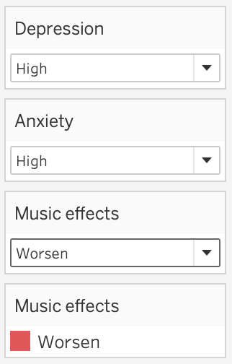

Figure 27: Boxplots of hours individuals reported listening to music across the highest levels of both anxiety and depression, filtered by the three music effects.

When the boxplots are centered on individuals who are listed as high for both depression and anxiety, the differences across listening hours becomes clearer, as it relates to and across the music effect categories. Individuals who report a positive impact from listening to music tend to listen to music for longer, while in contrast, the individuals who report that music worsens their levels of anxiety and depression tend to listen to music much less. These results align with and further extend the results already mentioned previously in this paper.

Lastly, it is important to look across the favorite genres to see if there is any relationship between music effects, hours spent listening to music, and favorite genres to see if the listening hours spent on favorite genres may be related to the worsening effect on mental health. The final level of analysis is presented in a tree diagram (Figure 28) that shows the number of hours spent listening related to various genres and their respective music effects. We noticed that rap stood out, as it has the largest number of hours listened reported by those experiencing a worsening mental health effect. Furthermore, we decided to look more closely at all the favorite genres in the worsening music effect category, namely rap, classical, rock, pop, and video game music.

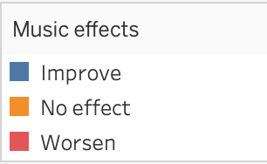 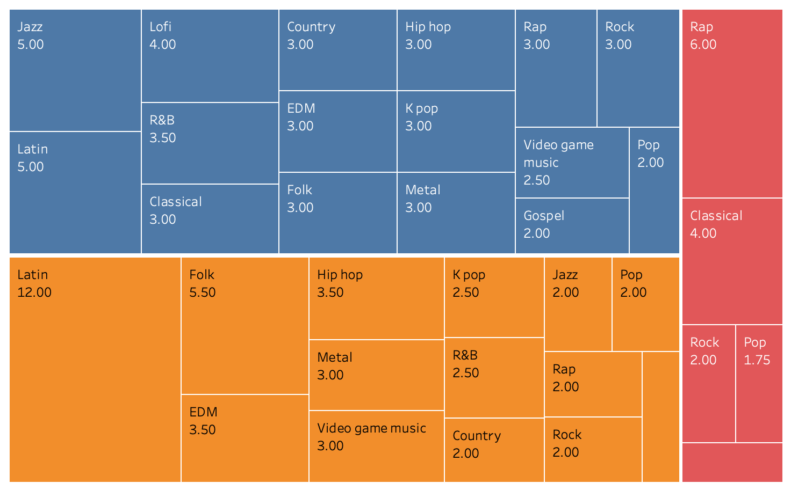

Figure 28: Tree diagrams of hours listened to music by music effects across all favorite genres.

In Figure 29, we see that rap and classical appear to have the highest number of listening hours in the worsen category, even in contrast to the listening hours reported by individuals in the neutral and improved categories for the same genre. These findings suggest that avoiding the genres of rap and classical music when developing playlists may be important to boost the benefits of music on mental health; however, these results are uncertain, as they are still based on survey, not experimental methods. These findings are purely relational and do not imply any causation between the music effects on mental health and the favorite genre and hours listening to music.

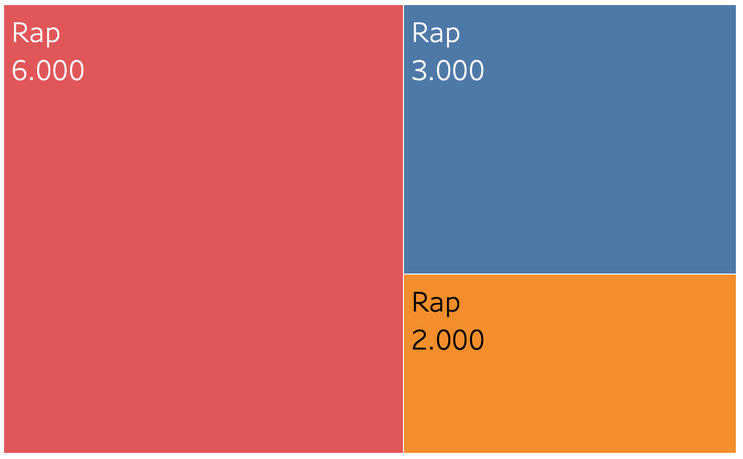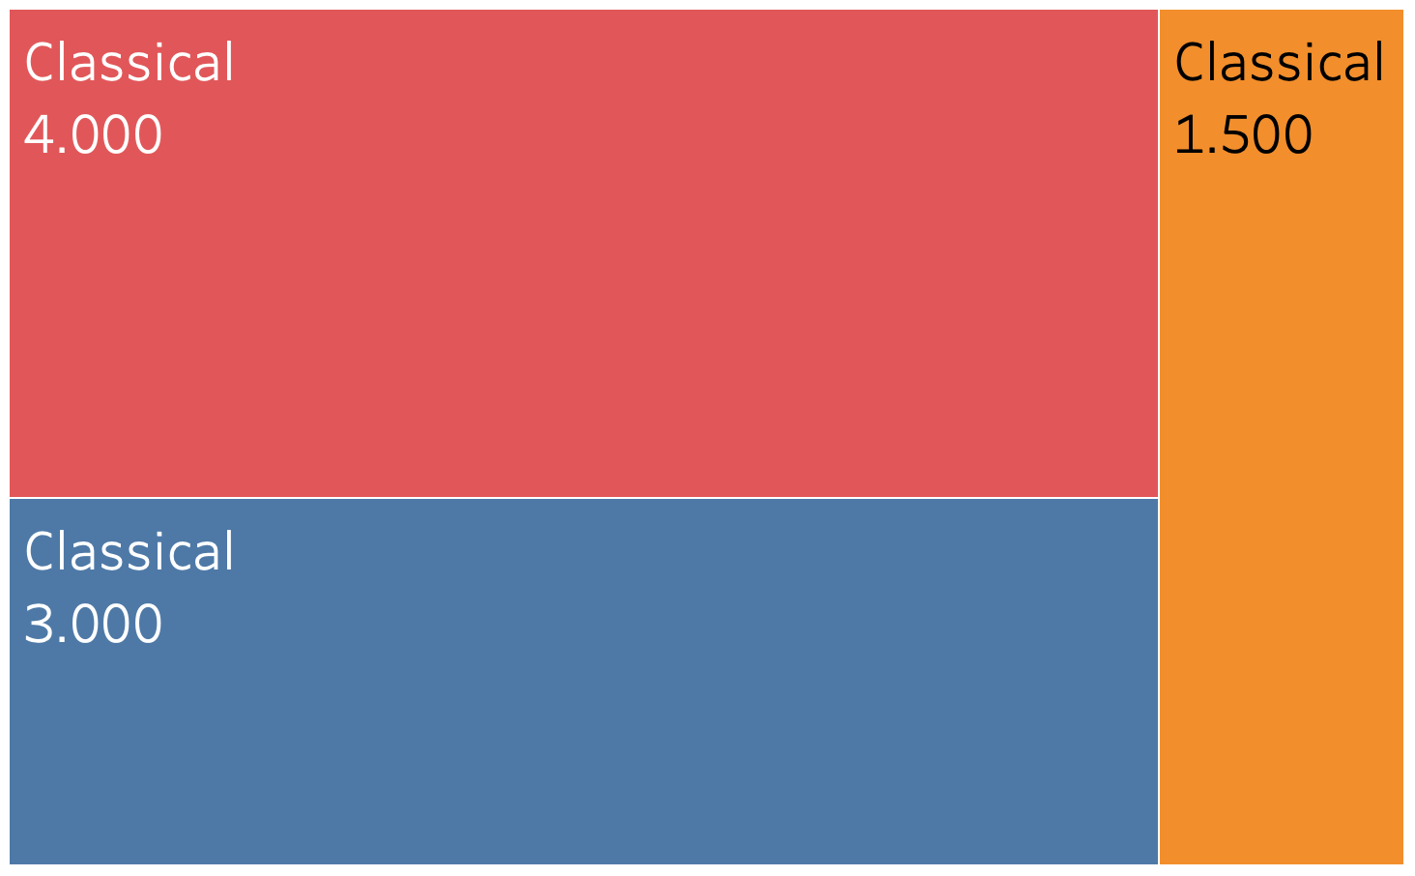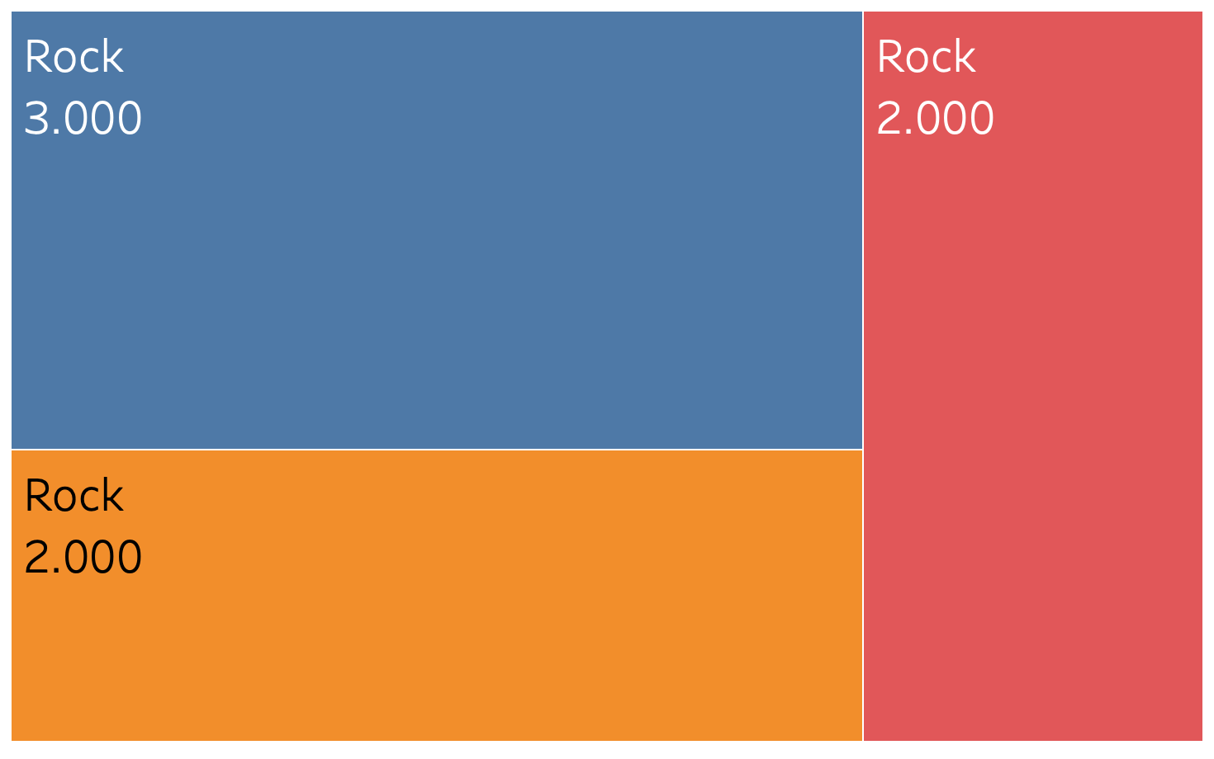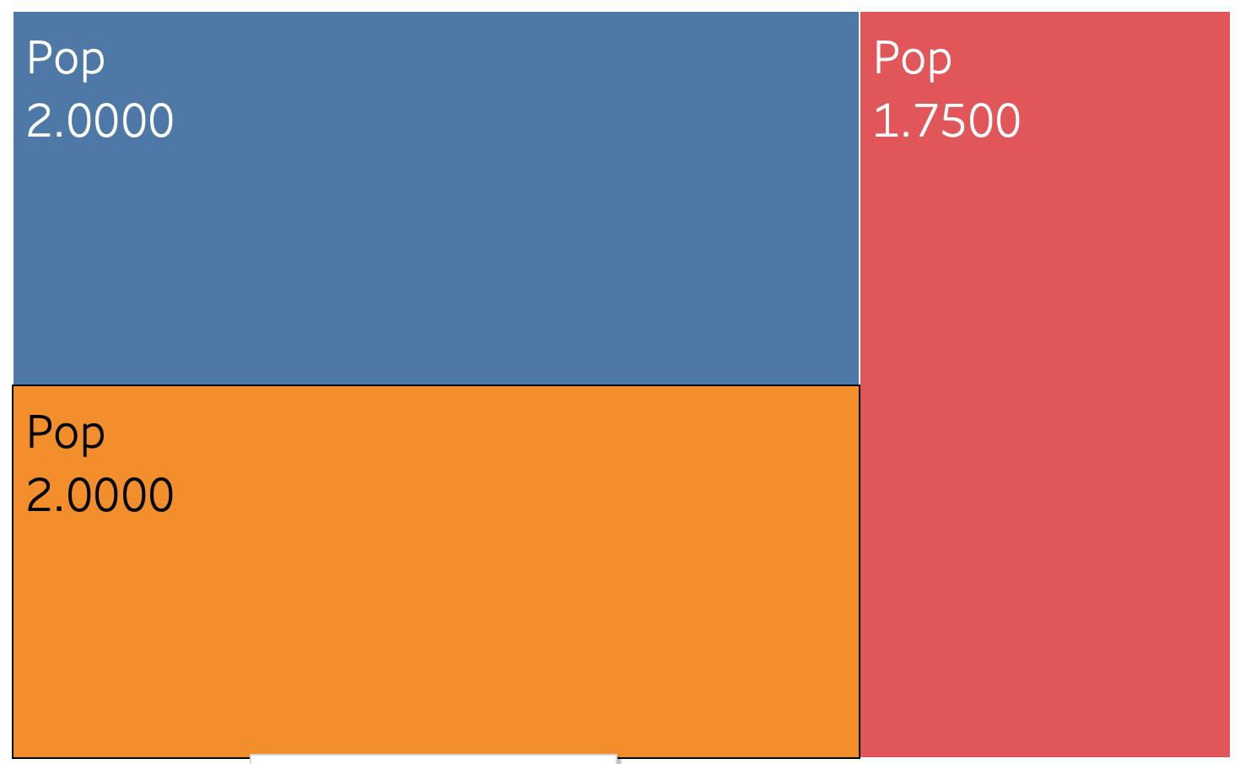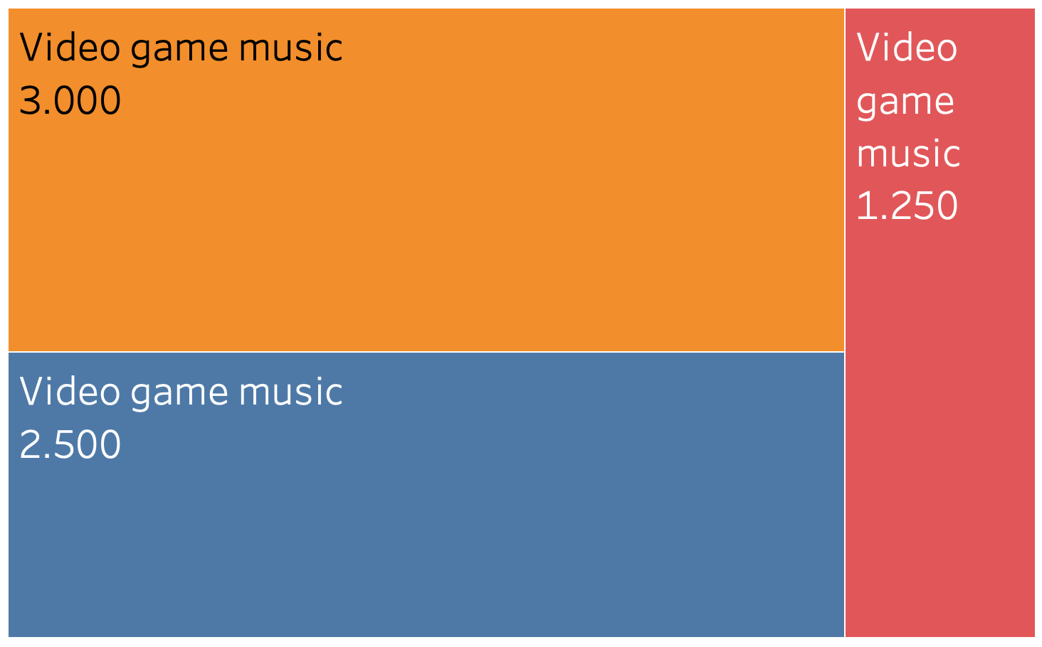

Figure 29: Tree diagrams of hours listened to music by music effects across the five genres in which individuals reported a possible worsening effect of music on mental health.

An important next step will be to design playlists that can be used as part of an experimental design to see how each genre across these playlists impact the self-reported anxiety and depression of individuals. Regardless, it is clear that individuals with mental health disorders recognize the importance of music in improving their mental health, and thus provide a strong level of support for the creation of our future streaming service.

# Milestones

1. **Brainstorming** - Our group met together and started brainstorming ideas on what kind of datasets we wanted to analyze. We each went to Kaggle and started searching for what interests us the most and compiled a document so each one of us could go through the list. We finally decided to pick [Music and Mental Health Survey](https://www.kaggle.com/datasets/catherinerasgaitis/mxmh-survey-results), as we all love music and are curious as to how it ties in with mental health. Additionally, we wanted to see how widespread mental health disorders can be and this has led us to find our supporting dataset, [Global Trends In Mental Health Disorders](https://www.kaggle.com/datasets/thedevastator/uncover-global-trends-in-mental-health-disorder).
2. **Pitch Presentation** - We created a Powerpoint presentation in order to pitch about our datasets to the entire class. Each group member decided on their own which parts they wanted to cover. We individually worked on the slides we were assigned and then finally grouped back together to practice for our presentation.
3. **Project Proposal** - Similarly, each group member picked parts that they wanted to write for the project proposal. After completing our parts, we reread each other’s works to check for consistency and provide any feedback.
4. **Final Presentation** - For our final work, we cleaned both datasets first, to ensure that all group members have the same file to work with. We discussed which variables we wanted to analyze based on what we had from our pitch presentation, and we each individually learned Tableau and/or R Studio to create our visualizations. Once our visuals were created, we updated our presentation slides, along with the final written paper. Finally, we practiced presenting to make sure we were all confident with our work.

# Key Takeaways

In summary, the important insights from our analysis and visualization are as follows:

* Anxiety and depression are the most prevalent mental health disorders and are interrelated.
* There has been no change in the rates of anxiety and depression over the past few years, based on survey data from 196 countries.
* Individuals with high anxiety and high depression demonstrate higher engagement with music.
* Music therapy has positive effects on mental health.
* The interdependence of depression and anxiety highlights a significant trend in hours spent listening to music.
* Most survey participants listen to music for 1 to 4 hours daily and report mental health benefits.
* Most participants reported listening to music in the “Moderately Fast BPM” category.
* Overall improvement in mental health was observed across all BPM classifications.
* Respondents who favor folk, kpop, and video game music reported higher anxiety levels; however, it is unclear if music causes this or if anxious individuals prefer these genres.
* Specific genres of music improve mental health.

# Discussion and Future Work

Based on our understanding of how the duration of music listening, preferred music genres, tempo, and platform preferences correlate with specific mental health disorders, we plan to use music therapy to tailor mental health interventions more effectively, as follows:

* **Target High Engagement Users :** Leverage the strong market potential by focusing on streaming platforms targeting individuals with high anxiety and high depression, given their high engagement with music.
* **Curate Therapeutic Playlists :** Develop playlists designed to alleviate mental illness, focusing on genres like country, edm, folk, gospel, hip hop, jazz, kpop, latin, lofi, and Metal. Minimize exposure to genres such as classical, pop, rap, rock, and video game music.
* **Age-Tailored Playlists :** Create playlists tailored to different age groups, recognizing that musical preferences vary across age demographics.
* **Optimize for Sensitive Listeners :** Optimize playlists for individuals whose anxiety and depression worsen with certain types of music, as these individuals tend to listen less.
* **Conduct Experiments :** Run experiments where participants listen to curated music and rate their overall mental health, to confirm and/or refine our strategy.
* **Address Related Mental Illnesses :** Recognizing the connection between anxiety and other mental illnesses such as schizophrenia, eating disorders, and drug-use disorders, we understand that solutions aimed at improving anxiety and depression may also benefit individuals suffering from these interrelated conditions.
* **Provide Data Insights in Phases :** Provide streaming platform partners with data insights and strategies for playlist curation, including timing, BPM, genre, and customization according to specific mental health disorders or conditions. This will enable the delivery of targeted music playlists in a phased manner as shown in the following visualization:

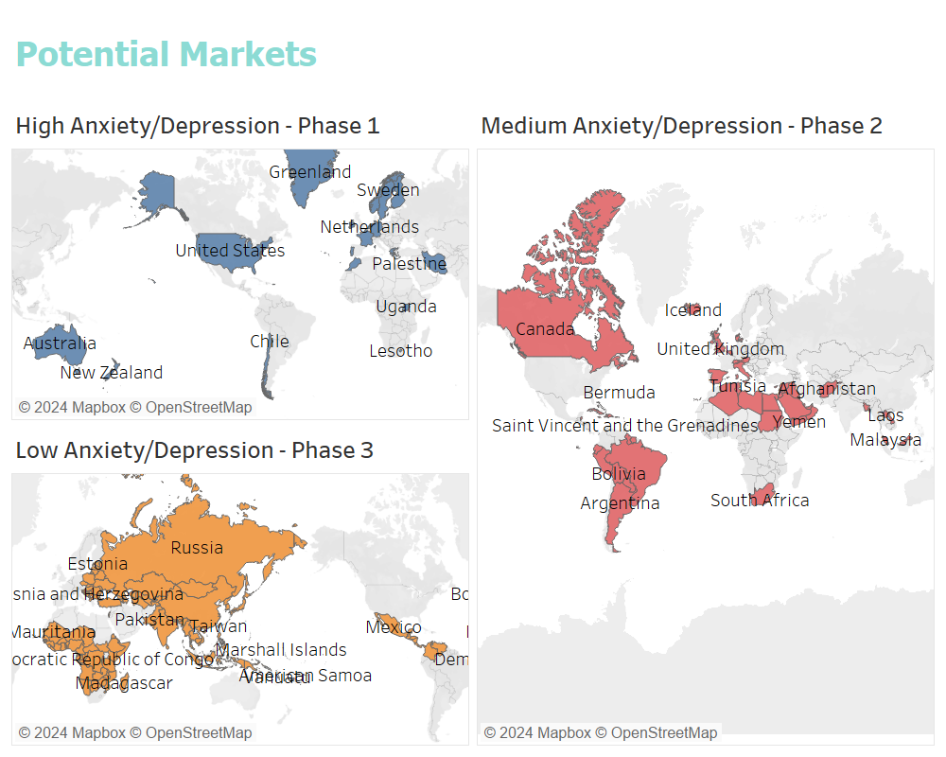

Figure 30: Future Market Potential

* Phase 1 : Target the 19 high anxiety and high depression countries.
* Phase 2 : Extend services to 9 medium anxiety and depression countries.
* Phase 3 : Expand to the rest of the world.

# Challenges

Based on the conclusions and recommendations, several challenges may arise:

1. **Data Privacy and Security :** Ensuring the privacy and security of user data, especially when dealing with sensitive information related to mental health.

2.  **Customization Complexity :** Developing highly customized playlists based on individual mental health conditions, preferences, and listening habits can be technically complex and resource-intensive.

3. **Effectiveness Validation :** Continuously validating the effectiveness of music therapy interventions and ensuring such treatment provides the intended mental health benefits.

4. **Cultural Differences** : Addressing cultural differences in music preferences and mental health perceptions globally across different regions.

5. **Engagement and Adoption** : Encouraging users, especially those with severe mental health conditions, to engage with and adopt the tailored music therapy solutions.

6. **Genre Sensitivity** : Managing the potential negative impacts of certain music genres on individuals with heightened sensitivity to specific types of music.

7. **Technological Integration** : Integrating data insights and customized playlists seamlessly into existing streaming platforms and ensuring compatibility across different devices.

8. **Scalability**  : Scaling the solution to cater to a global audience, while maintaining personalization and effectiveness.

9. **Stakeholder Collaboration** : Collaborating effectively with various stakeholders, including mental health professionals, music therapists, and streaming platform providers.

10. **Ethical Considerations** : Navigating the ethical considerations of using music therapy as an intervention for mental health issues and ensuring that it complements, rather than replaces, traditional treatments.

# Conclusion

In conclusion, leveraging music therapy to address mental health issues presents a promising avenue for improving well-being on a global scale. By utilizing data-driven insights to customize playlists according to specific mental health conditions, listening habits, and cultural preferences, we can create impactful, personalized interventions. While challenges such as data privacy, customization complexity, and cultural differences need to be addressed, the potential benefits of targeted music therapy for individuals with anxiety, depression, and related disorders are substantial. By collaborating with streaming platforms and mental health professionals, we can enhance the reach and efficacy of these therapeutic strategies, contributing to better mental health outcomes worldwide.

# Bibliography

* Catherinerasgaitis. (Retrieved February 13, 2024). MXMH Survey Results. Kaggle. Retrieved from<https://www.kaggle.com/datasets/catherinerasgaitis/mxmh-survey-results>
* Thedevastator. (Retrieved February 13, 2024). Uncover Global Trends in Mental Health Disorder. Kaggle. Retrieved from<https://www.kaggle.com/datasets/thedevastator/uncover-global-trends-in-mental-health-disorder>